PARTICIPANT GUIDE
myEvolv CS: Treatment Plan Tips and Tricks

Bob Sanderlin
Email: rsanderlin@ntst.com

Copyright © 2019 Netsmart Technologies, Inc. This material is only provided for the use of registered participants of the training event and should not be copied for, or distributed to, anyone not registered for the specific event in which it is used. Its content is the intellectual property of Netsmart Technologies, Inc. and is protected by copyright law. Permission to reproduce, distribute or use the content for other purposes should be directed to Netsmart Learning Services at learningservices@ntst.com.
Table of Contents

Icon glossary 2
Introduction 3
Learning Objectives 3
Designing Treatment Plans 4
Review 4
Tier Structure 6
Treatment Plan Components 9
Design Plan Components 15
Organize Plan Components 17
Treatment Plan Steps Designer 18
Treatment Plan – Form Designer 19
Treatment Plans Events 21
Services Set up By Program – Plan Setup 22
Treatment Plan Compliance Alerts 23
Linking Services to Treatment Plans 25
Addendums to Treatment Plans and Amending Events 27
Addendums 27
Amend Events 28
Routing Options Available in Treatment Plans 32
Route Name: NYC Treatment Plan Approval / Default Treatment Plans scheme 32
Route Name: NYSCRI Treatment Plan Routing 36
Treatment Plan Reports 42
Client Treatment Plan Reports 42
Plan Goals Report 42

Icon glossary
The following icons are used in this guide.
Icon | Usage
Tip | Highlights information that can save you time or make it easier to do something.
Key Information | Highlights important information that must not be missed by the user.
Best Practice | Provides a recommendation for a course of action that is either most efficient or will give the user the best results.

Introduction
This course is designed as an outline of best practices and standard design aspects of client treatment planning. Broad overviews of treatment planning are discussed from designing and organizing plans to incorporating workflows, compliance and reporting, utilizing libraries, assessment domains, and modifying existing plans.
Key Information: Before implementing any of the following features in your production system, it is required that you first test all aspects of setup and outcomes in your development system.

Learning Objectives
By the end of this course, the participant will be able to:
    - Design treatment plans
    - Link services to treatment plans
    - Add treatment plan compliance alerts
    - Add an addendum to a treatment plan
    - Amend events
    - Run various treatment plan and service entry reports

Designing Treatment Plans

Review
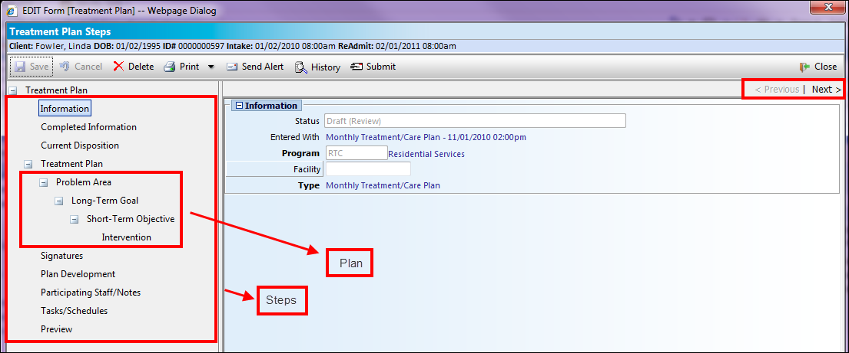
The navigation pane on the left side of the screen is similar to the Navigation panel to get to the different areas of myEvolv. You can click any step to move to that form or use the Previous/Next buttons in the upper right corner to step through the plan.
The various steps of a plan are really individual forms that can be ordered in any way based on user preference. These forms can be modified or copied to make custom forms using the Form Designer.
The treatment plan itself is a step, which in turn is made up of various component forms. Component forms can be modified or copied to make custom forms using Design Plan Components. The component forms are organized in a tier structure hierarchy which can be set up to meet individual agency and/or program needs.
This example shows a tier structure that uses all four tiers available and illustrates that your agency can use your own naming conventions for the different tiers. These four tiers are arranged in a Parent-Child relationship. You can have several children related to each parent step.
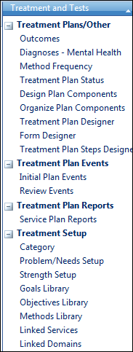
Treatment libraries and supporting data
Plan Events
Plan Setup areas

Outcomes | This is a shortcut to the Table Maintenance table called Outcomes/Result and is used in multiple places in myEvolv (such as Event Outcome and Discharge Outcome) based on the check boxes selected.
Diagnoses – Mental Health | This is a shortcut to the Diagnosis Setup area and lists only those diagnoses flagged as ‘Is Mental’.
Method Frequency | This table is used in the Method/Intervention tier of a treatment plan.
Treatment Plan Status | Every goal, objective, and method defined in a plan can be given a status. This status is also used for aggregate reporting by status. During the Treatment Plan Review, you can deselect parts of a treatment plan if they have a certain status (Achieved or Discontinued).
Libraries | Based on the component form selected for each tier, the user may choose from libraries of predefined values for the various component fields (Area of Treatment, Goal, Objective, and Method). These predefined values allow for standardization in plan creation and help staff develop the plans by presenting them with appropriate values.
Category | This is the highest level in the tiers and is used to filter other values. You can create new categories or create an N/A category to use no categories, essentially. Categories can be linked to specific programs if desired.
Problem/Needs Setup | We often see that goals on a plan are designed to address a specific problem that the client has. Even if you are not linking the problem to a goal, you can enter problems on the client’s record for other uses. The problems library allows you to group the problems under different categories and create standardized descriptions that you can report on.
Strength Setup | Treatment Planning can be strength-based, rather than problem-based, and strengths can be grouped into categories just like problems.
Goals Library | Goals are created and edited the same way as problems.
Objectives Library | Objectives are created and edited the same way as problems.
Methods Library | Methods are created and edited the same way as problems.

Tier Structure
Each tier relates to a component form in myEvolv.

Example 1
Area of Treatment

Method (multiple methods for an objective)

Objective (multiple objectives for a goal)
Goal (multiple goals within an area of treatment)

Example 2
Goal

Objective (multiple objectives for a goal)

Method (multiple methods for an objective)

Example 3
Goal

Objective (multiple objectives for a goal)

Example 4
Goal

Method (multiple methods for a goal)

Example 5
Goal

Goal (multiple sub-goals for a goal )

Objective (multiple objectives for a goal)

Example 6
Long Term Goal

Intervention (multiple methods for a goal)

Short Term Goal

Intervention (multiple methods for a goal)

- Navigate to Setup > Treatment and Tests > Treatment Plans/Other > Treatment Plan Designer.
- Click Area of Treatment.
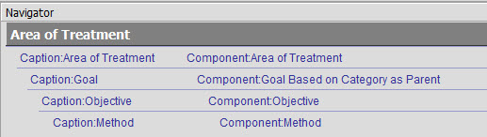
This is Example 1 above.
- Click each level and note the component form that is used.
- Repeat this action for each of the following items as we discuss each.
- Goals Only
- Individual Service Plan for DSR
- Initial Agency Plan
- Long and Short Term Goals with no Library
- Long and Short Term Plan
- Plan with No Library
- Scanned Plan
- Strength Based Plan
- Training DSR
- Training Scheduled Svcs
- Treatment Plan
Tip: There is a component form available that merges the Category (Area of Treatment) and Goal forms into a single component form. It is a system form but can be copied and modified.
- Click the New Treatment Plan.
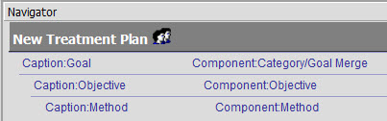
- Preview the New Treatment Plan.
- This form uses the typical four tiers (Category/Goal/Obj/Method) but reduced it to three tiers for a more user-friendly treatment plan.
- The Goal/Objective/Method libraries will refresh if the category is switched during plan creation.
- The category has to be chosen at each goal level. For example, if you have five goals, you have to choose a category for each.

Treatment Plan Components
Now that we have discussed the tier structure, let’s look closer at the forms for each tier. Each tier has one or more Netsmart-supplied component forms that you can use.
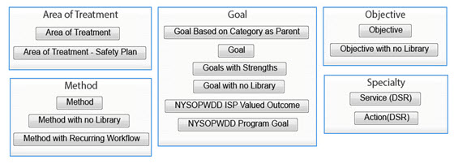

Area of Treatment/Category
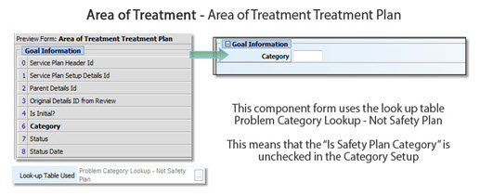

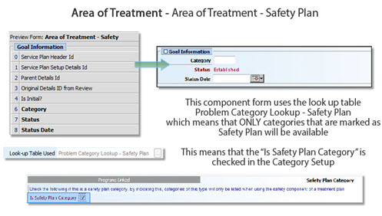

Goal
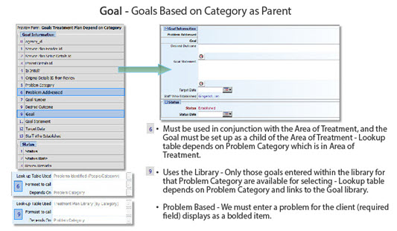
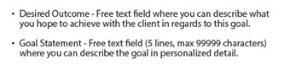

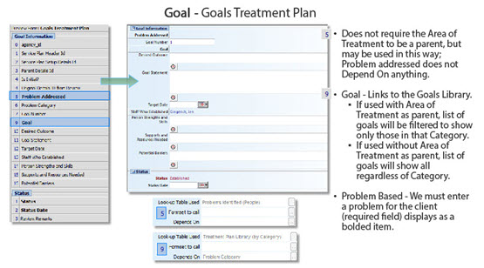

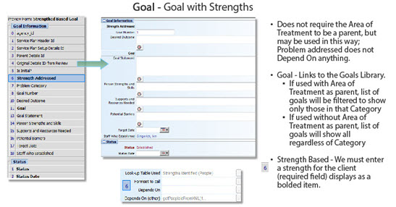

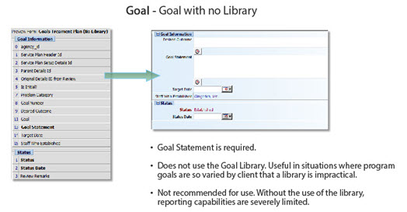

Objectives
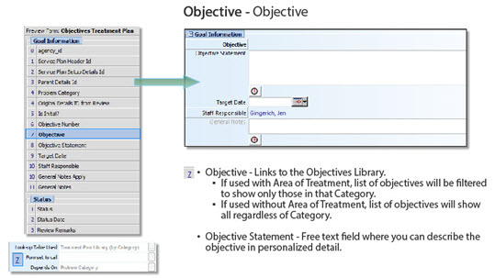

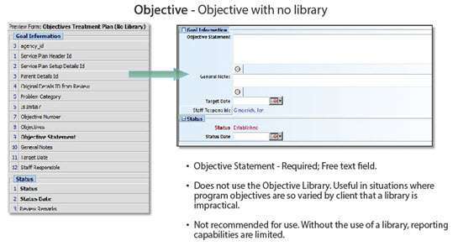

Method
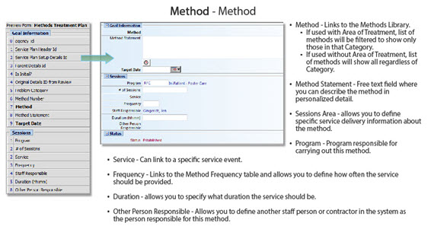

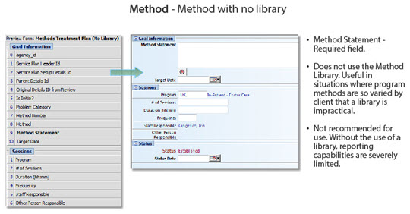

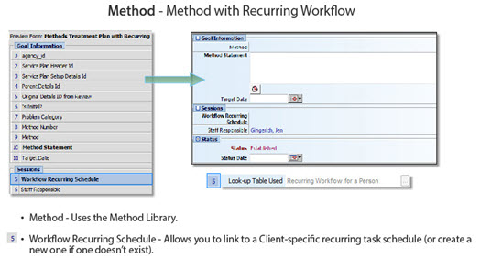

Specialty Forms
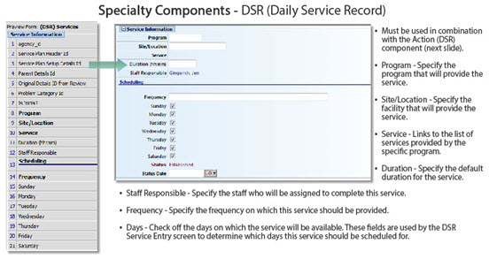

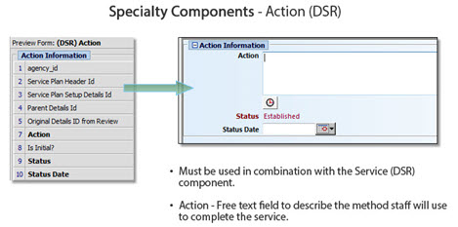

Design Plan Components
myEvolv allows you to copy system component forms and modify them as desired.
- Navigate to Setup > Treatment and Tests > Treatment Plans/Other > Design Plan Components.
- Click Open and select Treatment Plan Details.
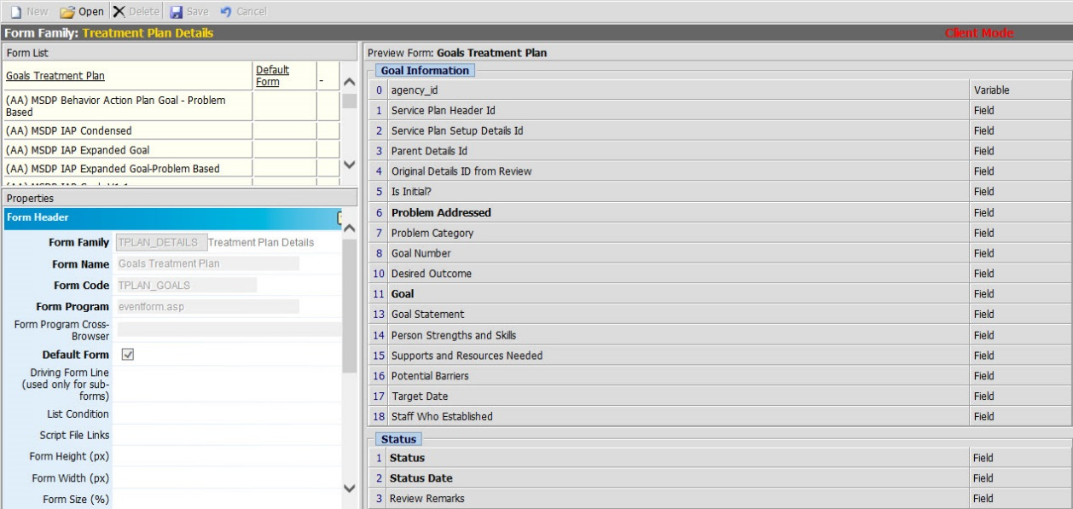
This is basically form designer for the treatment plan component forms.

- Right-click Goals Treatment Plan Depend on Category and select Copy Form.
- Enter the following:

Form Name | Goals# (where the # is your assigned number)
Form Codes | Goals#

- Click Save.
- Select your new form.
- Select the Problem Addressed field.
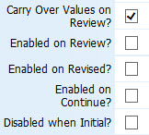
Carry Over Values on Review? - When checked, data entered on the previous plan (initial or review) will appear in subsequent reviews. If this field is not checked, this field will be blank on reviews.
Enabled on Review? - When checked, this property will allow you to modify this field on reviews. If this field is not checked, you will not be able to edit this value on a review.
Enabled on Revised? - When checked, this property will allow you to modify this field when a component has a status of Revised.
Enabled on Continue? - When checked, this property will allow you to modify this field when a component has a status of Continued.
Disabled when Initial? - When checked, the field will be disabled (Read only) on the Initial plan or when the component is created (when the status is established). On review, the field will become enabled. This can be used when the same form will be used for initial and review events, but the field only applies to reviews.
- Click Save.

Organize Plan Components
When you create a new component, as we did by copying an existing one, you have to associate that new component with the proper library.
- Navigate to Setup > Treatment and Tests > Treatment Plans/Other > Organize Plan Components.
- Click New then Treatment Plan Component – User.
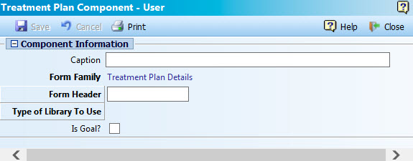
- Enter the following:

Caption | Goals# (this is what appears in the Treatment Plan Designer).
Form Header | Select your form.
Type of Library to Use | Goal (this tells myEvolv to use the Goals Library).
Is Goal? | Click the check box.

- Click Save. You can now use your new form in the Treatment Plan Designer.

Treatment Plan Steps Designer
We have looked at the Treatment Plan tier structure. Now we will look at the steps that surround the Treatment Plan.
- Navigate to Setup > Treatment and Tests > Treatment Plans/Other > Treatment Plan Steps Designer.
- Click Treatment Planning (TEMPLATE – DO NOT TOUCH).
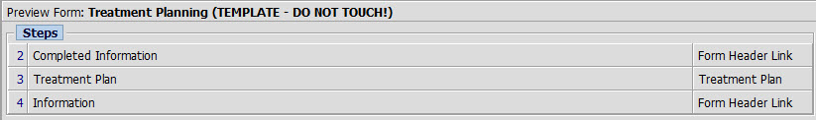
These are the steps that automatically get added to any new treatment plan you create.
- Click the Completed Information and Information steps to view the Form steps associated with each.
- Click New Treatment Plan. This uses the Category/Goal Merge component we looked at earlier.
- Right-click > Copy Form the New Treatment Plan form.
- Enter the following:

Form Name | NewTP# (where the # is your assigned number)
Form Codes | NewTP#

- Click Save.
- Select your new form.
- Right-click > Insert Form Header After on Completed Information.
Some of the more common forms to add are:
- Treatment Plan – SIGNATURE_PAGE (for manual signatures)
- Treatment Plan – Signatures (for signature pad)
- Plan Development (to add plan development services – make sure to link the Plan Development service to the program as well. You do not need to create the event, though, as it is already a System Not Modifiable event.
- Current Disposition
Note: There is also a new form available here. Where we have two steps for Completed Information and Information, there is now a combined form which has both. Very similar to the merge for the Category/Goal tier, this new form helps to simplify the treatment plan structure.
- Information (Consolidated)
- Add the following forms to your treatment plan in whatever order you want.
- Treatment Plan – Signatures
- Plan Development
- Current Disposition
- Information (Consolidated)
- Click Save.

Treatment Plan – Form Designer
Just like any form in myEvolv, the forms in the treatment steps can be modified and copied.
- Navigate to Setup > Treatment and Tests > Treatment Plans/Other > Form Designer.
- Click Open and select Treatment Planning (NEW).
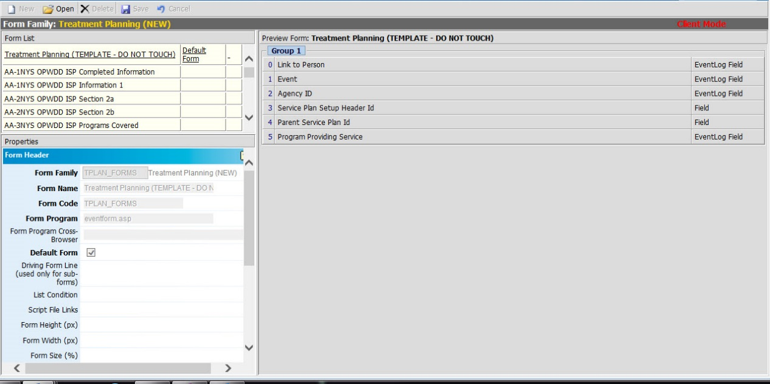
Here is where the forms in the Treatment Plan Steps live.
- Click Information Consolidated.
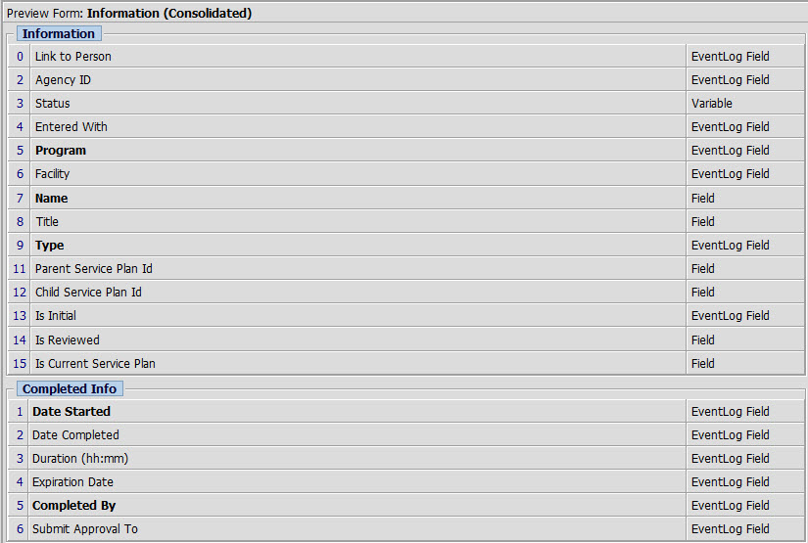

Treatment Plans Events
The only difference between Treatment Plan events and other events in myEvolv is that for Treatment Plans you must create one Initial and at least one Review event to enter and review Treatment Plans.
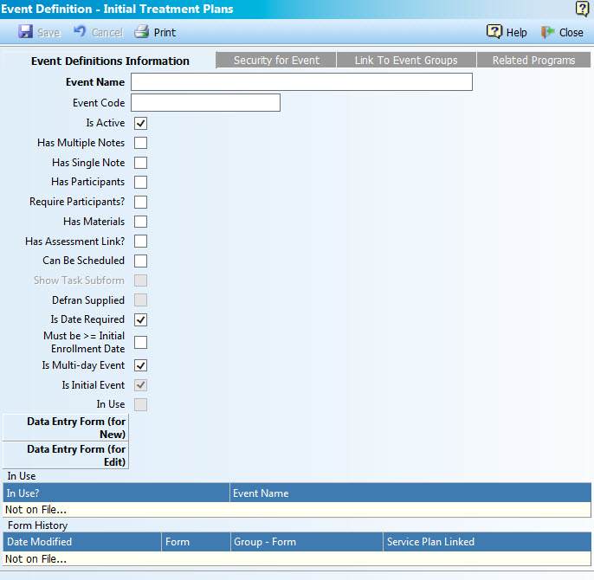

What fields do you select when you create your Treatment Plan events, and why?

Services Set up By Program – Plan Setup
Since there can only be one Treatment Plan (initial and multiple review) for each program, it can be challenging to make changes to your Treatment Plan design after you have begun using the plan.
Tip: Be sure to keep the old treatment plan review event in the Ongoing events area so any existing clients in that program can continue to be reviewed with the old form.
Any new clients would automatically get the new initial event.
- Navigate to Agency Setup > Services Setup > By Program > Plan Setup.
- Right-click > Edit the Counseling Services program.
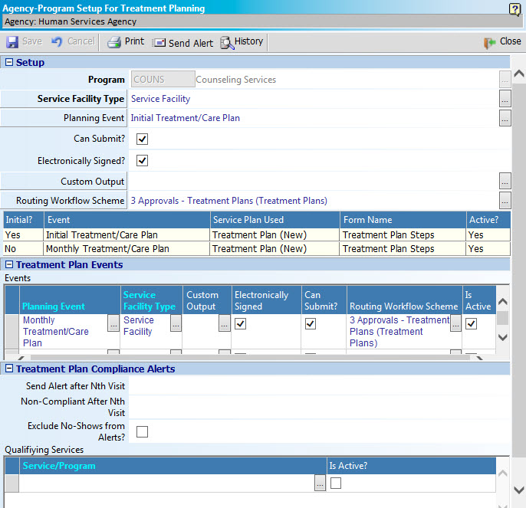
- Custom Output is for a few outputs so will not usually be selected.
- Routing Workflow Scheme will be covered a little later in this course.

Treatment Plan Compliance Alerts
Agencies can alert a client’s primary workers as to whether or not they are completing treatment plans in a timely manner based upon rules that the agency defines.
Here the agency defines the following items.
- Number of visits/service contacts with a client before an alert is sent to their primary worker
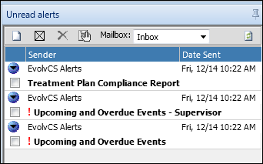
- Number of visits/service contacts that defines when a primary worker is out of compliance.
- Excluding no-show services from calculation.
- The service that is to be tracked in combination with a client’s treatment plan process.

When a client has a treatment plan on file that is associated with the program setup and there are services on file that have been defined in the program setup, the client’s primary worker will receive a daily alert (this runs as part of the daily tickler alerts). The alert will have the subject ‘Treatment Plan Compliance Report’.
The contents of the alert will show, based upon the count of services, whether or not the worker is in compliance with the agency’s treatment plan rules.
The legend for a compliance alert is as follows:
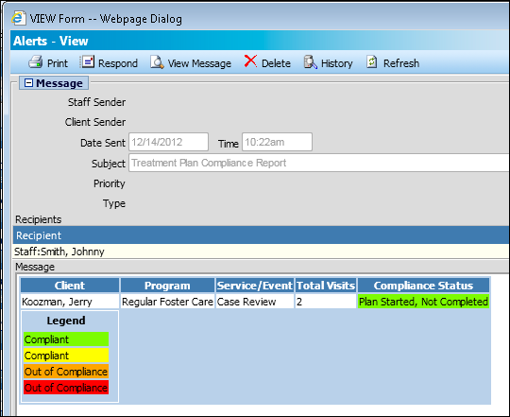
- Green – Compliant; the client has a treatment plan on file which is not complete (approval process setup with workflows is complete) and the compliance # of visit threshold is not crossed.
- Yellow – Compliant; the client does not have a treatment plan started or on file and the compliance # of visits threshold is not crossed.
- Orange – Out of compliance; threshold # of visits is crossed and the client has an incomplete treatment plan.
- Red – Out of compliance; threshold # of visits is crossed and the client has no treatment plan started or none on file.

Linking Services to Treatment Plans
One way to link a service to the Treatment Plan is on the Event Definition screen by selecting the Has Treatment Plan Link check box.
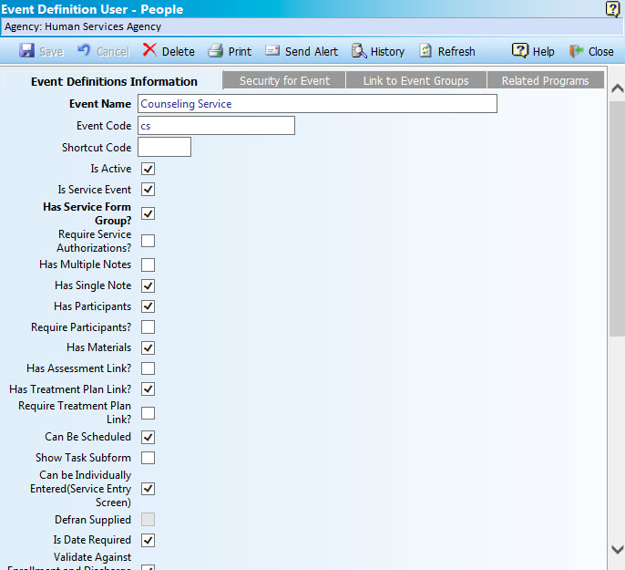
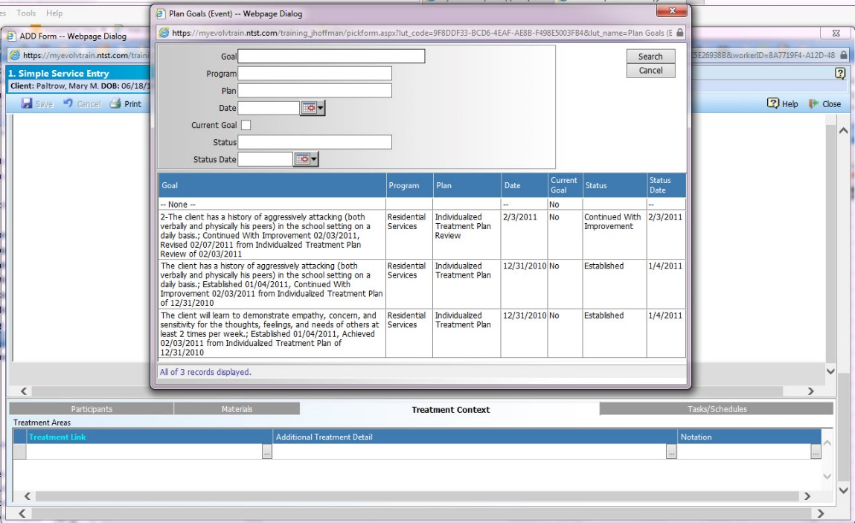
However, this will only allow us to link to Goals/Objectives/Methods that are in the treatment plan for that particular program we are entering the service for.
There are subforms in myEvolv that you can add to any service event form that allow you to link that service to a Goal/Objective/Method in ANY Treatment Plan (regardless of the program).
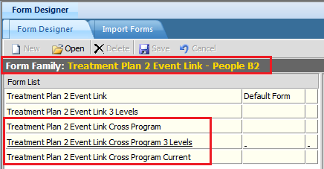
- Treatment Plan 2 Event Link Cross Program: Allows linkage of ‘Goal only’ from any treatment plan ever entered on the client’s profile.
- Treatment Plan 2 Event Link Cross Program 3 Levels: Allows linkage of Goal/Obj/Method from any treatment plan ever entered on the client’s profile.
- Treatment Plan 2 Event Link Cross Program: Allows linkage of ‘Goal only’ from currently active Tx Plans (not discharged/ended program plans).

Addendums to Treatment Plans and Amending Events
Once a Treatment Plan has been complete and finalized, it is locked/eSigned and should not be changed for any reason. But, what if you need to add information and you don’t want to do a review?

Addendums
Treatment plan Addendums allow you to add narrative that is linked to the completed treatment plan.
- Navigate to Client > Case Management > Plan Development > Plan Addendums.
- Search for/select the client ‘Mary Paltrow’.
- Click New Manual Event then Service Plan Addendum.
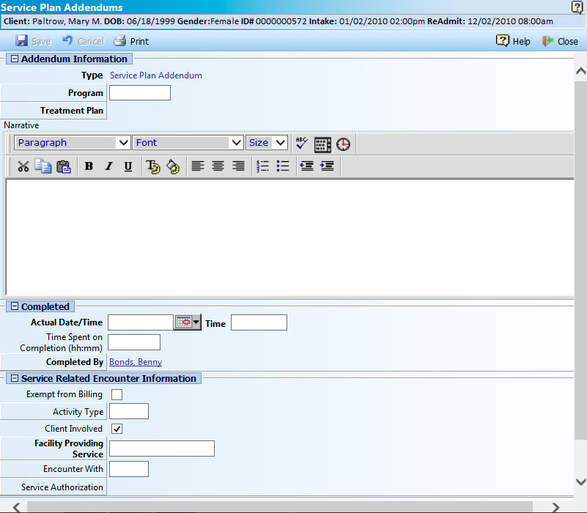
- Enter the additional information and complete the required fields.
- Click Save.
By adding the Service Plan Addendum Subreport to the Completed Information form, you will be able to view any addendum with the completed information.
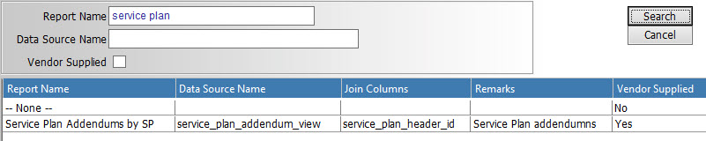

Amend Events
The myEvolv Amend feature allows you to add an amendment to an approved service and maintain the original service as-is without having to unsign the event, edit, and resubmit. This provides an accurate audit trail.
Step 1 – Set Up Amend Worker Role Security for the Event
Step 2 – Amend a Service Event
- Navigate to Client > Case Management > Service Management > Service Entry.
- Click Select Client then search for/select the client.
- Navigate to a row for the completed event that you added the amend security for.
The represents the Amend option.
- Click . The Event Amended window opens.
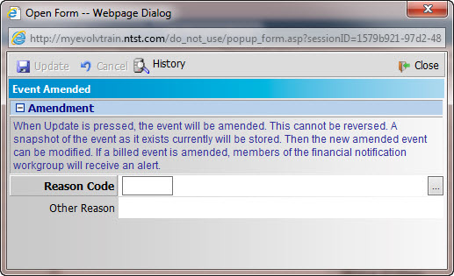
The text at the top of the window notes that once the Update button is clicked, the event will be amended and cannot be reversed. This stores a snapshot of the event at it exists currently for audit purposes.

- Click Reason Code and select the appropriate reason you are amending the event.
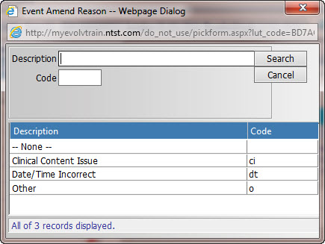
Note: If you select Other in the Reason Code, you should enter the Other Reason in the second field.
- Click Update. A new amended event opens and allows you to make the needed changes.
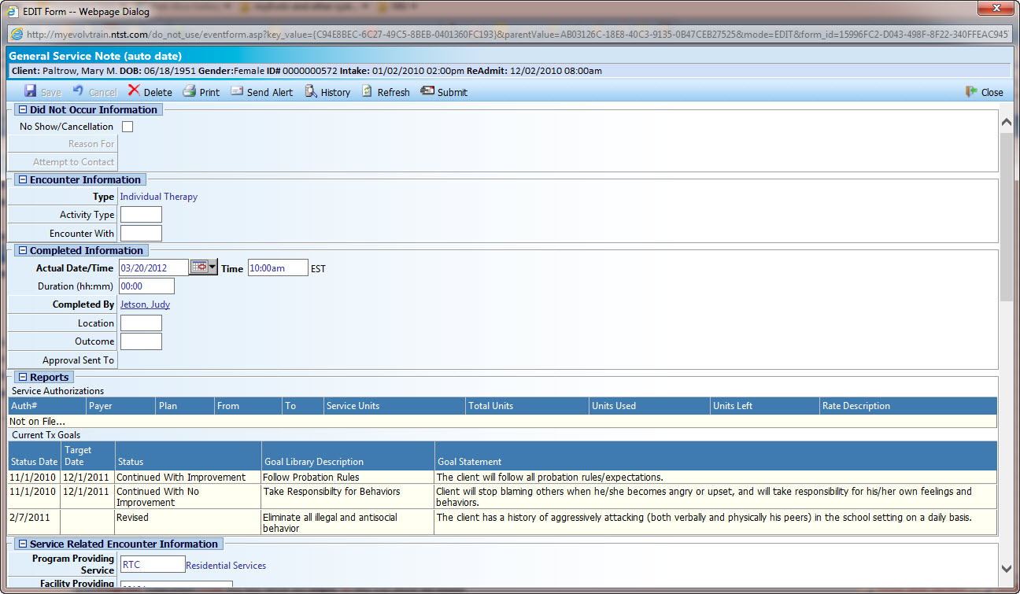

- Click Save.
The original event now appears with a strikethrough and the recycle icon in the column at the left. If you hover over the row, the following statement displays.
This event was amended.
The newly created event is now available to be submitted for approval.

View the Original Event and Audit Trail
- Click the original event to open it.
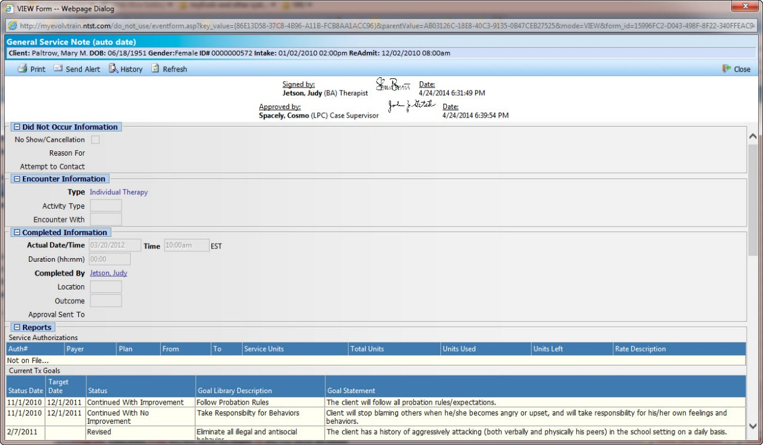
All fields are disabled so no changes can be made. This is a snapshot of the event that was amended prior to the Amend request.
- Click History then Display Audit Trail.
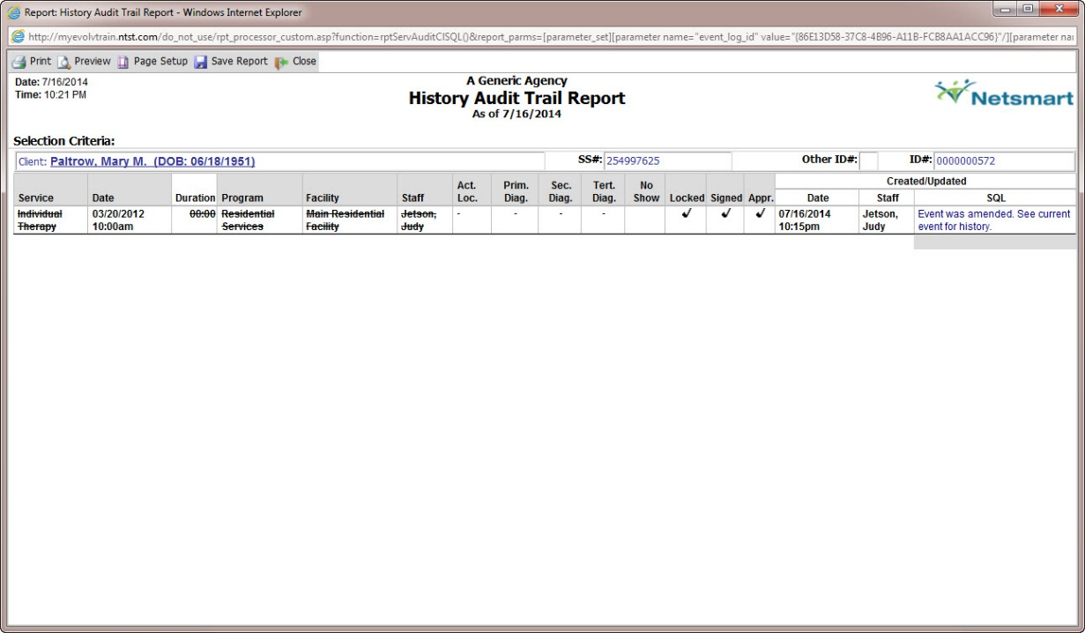

Routing Options Available in Treatment Plans
Routing offers agencies an alternative way to submit a treatment plan for review.
- For Treatment Plans – In the example shown here, you would use either the traditional submit process (the NYC Treatment Plan – 3 Approval), or the NYSCRI Treatment Plan Routing scheme.
- Updated routing options are outlined in the Clinical and Finance Routing Guide on the Netsmart wiki.

Route Name: NYC Treatment Plan Approval / Default Treatment Plans scheme

Overview
The purpose of this routing is to provide three signatures/levels of review on a treatment plan (clinician, supervisor, MD). The route provides the traditional Route for Supervisor Review (from which any supervisor can be selected). Once approved by the Supervisor, the Treatment Plan is then routed to an MD workgroup. Any MD in the workgroup can review and approve the Treatment Plan. Once approved, it is out of the queue for all MDs and is complete.
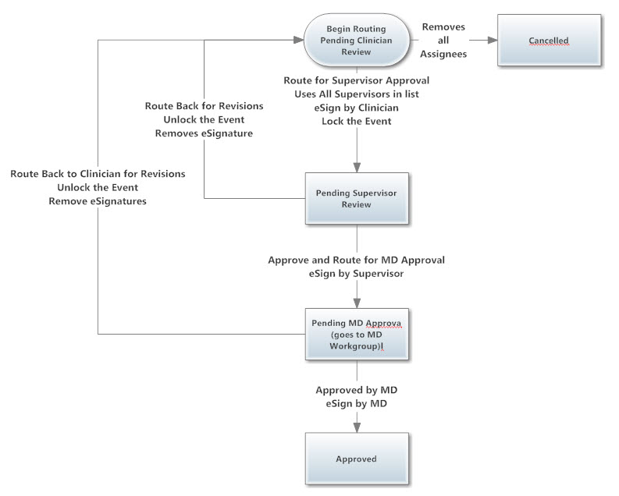

Setup
The MD Workgroup named ‘Medical Doctors’ (note, the name needs to be exact) needs to be created and populated with anyone who will be responsible for MD approval.
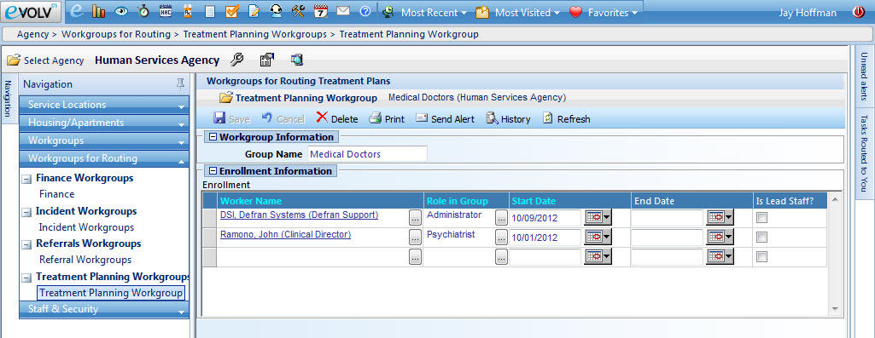

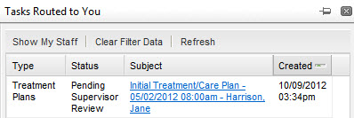
Location in the system

Routing pane
The main location for routing tasks is in the routing pane. The Routing Pane is designed to allow users to work with the tasks routed to them, either directly or via a workgroup.

Routing Actions
There are several routing actions available for the user to complete the review process on the Treatment Plan. They are available by clicking the Routing Actions button in the Treatment Plan toolbar.

Clinician Actions
Submit the Treatment Plan for Supervisor Approval:
- After saving the treatment plan, click Route for Supervisor Review.
- Click the Supervisor drop-down and select the person to forward the Treatment Plan to.
- Type a note.
- Click Route for Supervisor Review. This will lock the Treatment Plan, add the clinician’s eSignature, and send it to the selected Supervisor’s Routing Pane for review.
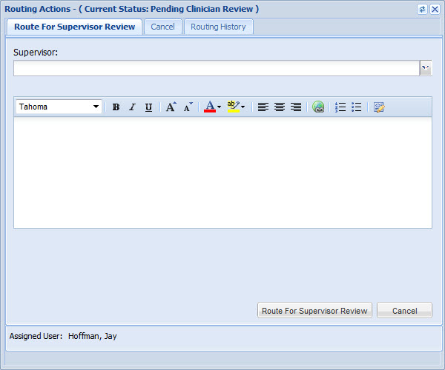

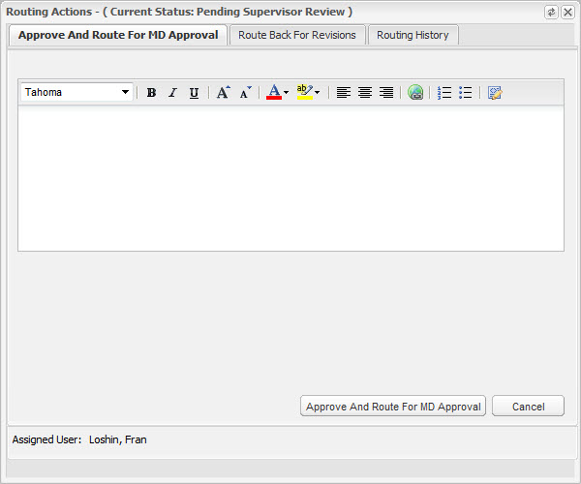
Supervisor Review Actions
The Supervisor has multiple actions.
- Approve and Route For MD Approval
- Route Back for Revisions
Approve and Route For MD Approval
Used to send the treatment plan to the MD Workgroup for review and approval.
- Click the Approve and Route for MD Approval tab.
- Enter a note.
- Click the Approve and Route For MD Approval button. This will add the Supervisor’s eSignature and send it to the Routing Pane of anyone in the MD Workgroup for review.
Route Back For Revisions
Used to send the treatment plan back to the clinician to make revisions.
- Click the Route Back For Revisions tab.
- Enter a note.
- Click the Route Back for Revisions button. This will unlock the Treatment Plan and send it to the Routing Pane of the original clinician for revisions.

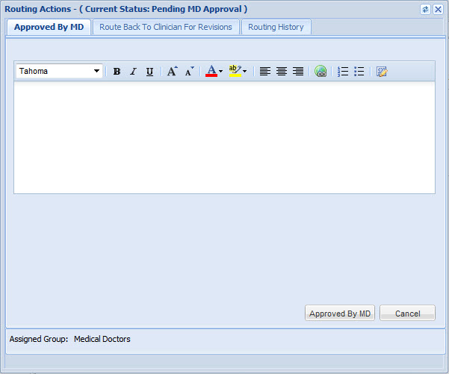
MD Workgroup Review Actions
The MD has multiple actions.
- Approved by MD
- Route Back To Clinician For Revisions
Approved by MD
Used for final approval.
- Click the Approved by MD tab.
- Enter a note.
- Click the Approved by MD button. This will add the MD’s eSignature and close the Treatment Plan.
Route Back To Clinician For Revisions
Used to send the treatment plan back to the clinician to make revisions.
- Click the Route Back To Clinician For Revisions tab.
- Enter a note.
- Click the Route Back To Clinician for Revisions button. This will unlock the Treatment Plan and send it to the Routing Pane of the original clinician for revisions.

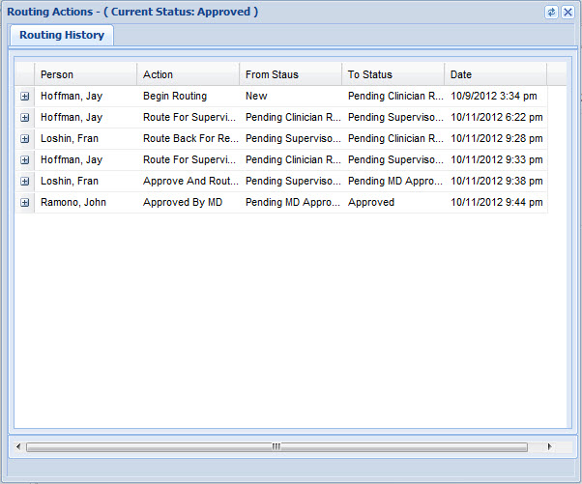
Routing History
Routing History provides an audit trail of the actions performed along with any notes that were added.
Access Routing History:
- Click the Routing History tab.
- Click on any row to expand and view any notes that were added during routing.

Route Name: NYSCRI Treatment Plan Routing

Overview
The purpose of this route is to provide four signatures/levels of review on a treatment plan (clinician, supervisor, QHP/Professional, MD). The route provides the traditional Route for Supervisor Review (from which any supervisor can be selected). Once approved by the Supervisor, the Treatment Plan is then routed to a member of the Treatment Plan Workgroup for QHP/Professional Review or directly to a member of the MD Workgroup. If sent for QHP/Profession Review, the member of the Treatment Plan Workgroup then sends it on a member of the MD Workgroup for approval. Once approved by a member of the MD Workgroup, it is complete.
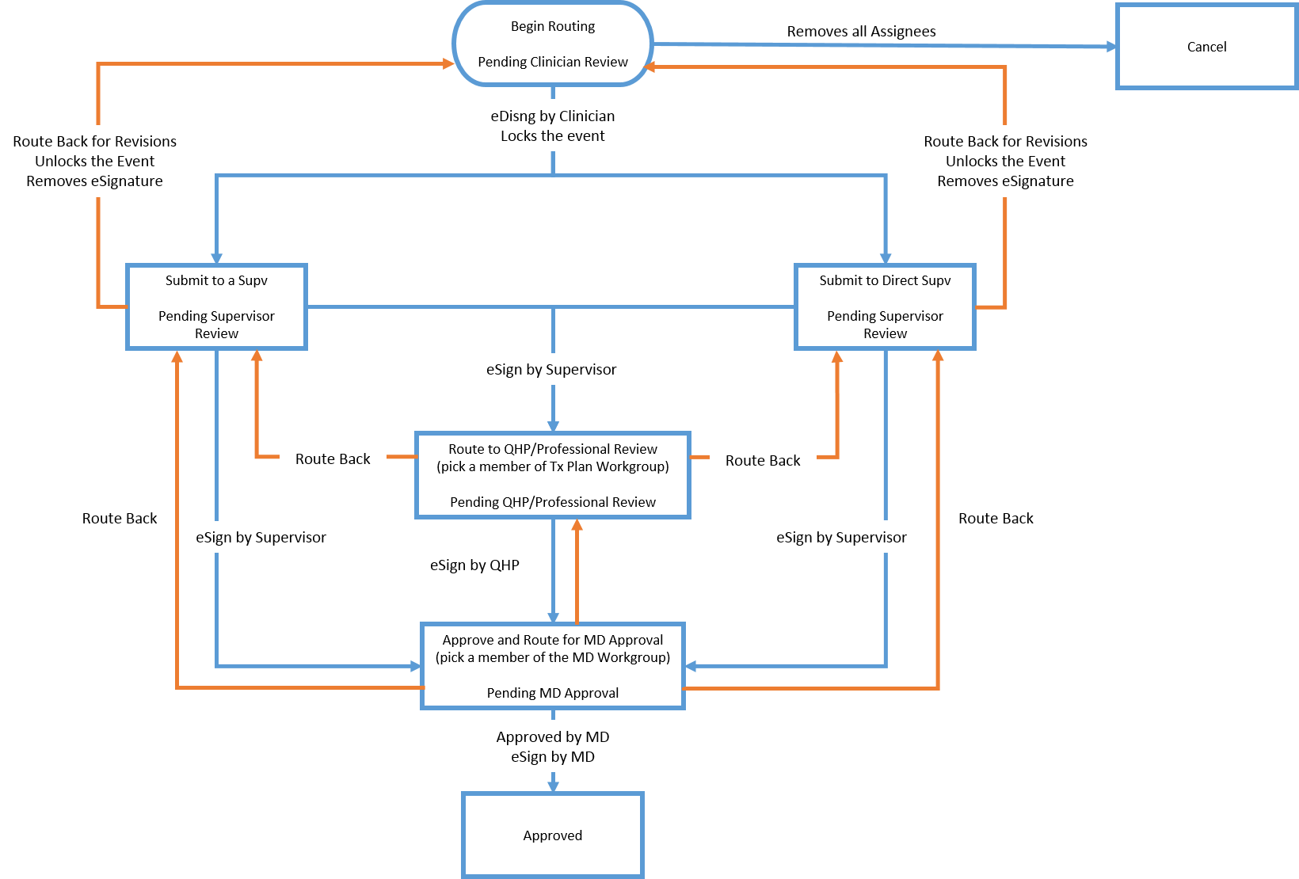

Setup
Two workgroups need to be created for this route.
- Medical Doctors – This workgroup name must be exact
- Treatment Plan Workgroup – This workgroup name can be anything as long as it contains ‘treatment plan’ in the name

Medical Doctors Workgroup
The MD Workgroup named ‘Medical Doctors’ (note, the name needs to be exact) needs to be created and populated with anyone who will be responsible for MD approval.

Treatment Plan Workgroup
The Treatment Plan Workgroup needs to be created and populated with anyone who will be responsible for QHP/Professional Staff approval.

Location in the system

Routing pane
The main location for routing tasks is in the routing pane. The Routing Pane is designed to allow users to work with the tasks routed to them, either directly or via a workgroup.

Routing Actions
There are several routing actions available for the user to complete the review process on the Treatment Plan. They are available by clicking the Routing Actions button in the Treatment Plan toolbar.

Clinician Actions
The Supervisor has multiple actions.
- Submit the Treatment Plan for Supervisor Approval (Direct Supervisor)
- Submit the Treatment Plan for Supervisor Approval (Any Supervisor)
- Cancel / Remove all Assignees
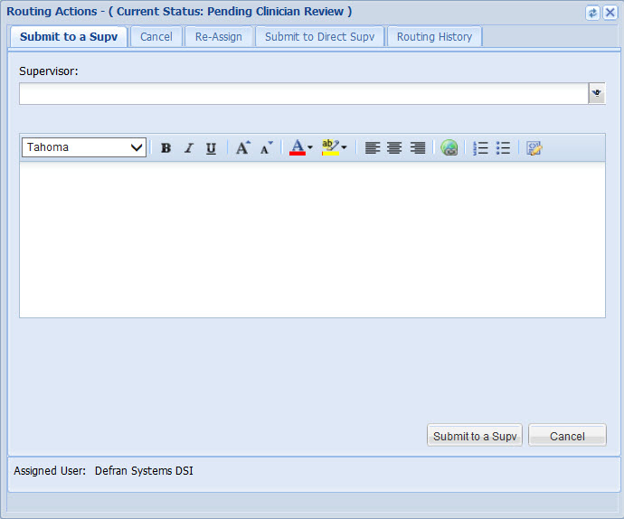
Submit the Treatment Plan for Supervisor Approval (Direct Supervisor)
- After saving the treatment plan, click Submit to Direct Supv.
- Click the Supervisor drop-down and select your supervisor
- Type a note.
- Click Submit to Direct Supv. This will lock the Treatment Plan, add the clinician’s eSignature, and send it to the selected Supervisor’s Routing Pane for review.
Submit the Treatment Plan for Supervisor Approval (Any Supervisor)
- After saving the treatment plan, click Submit to a Supv.
- Click the Supervisor drop-down and select the supervisor you want to submit the treatment plan to.
- Type a note.
- Click Submit to a Supv. This will lock the Treatment Plan, add the clinician’s eSignature, and send it to the selected Supervisor’s Routing Pane for review.
Cancel / Remove All Assignees
- After saving the treatment plan, click Cancel.
- Type a note.
- Click Cancel. This will remove the clinician as the assignee.

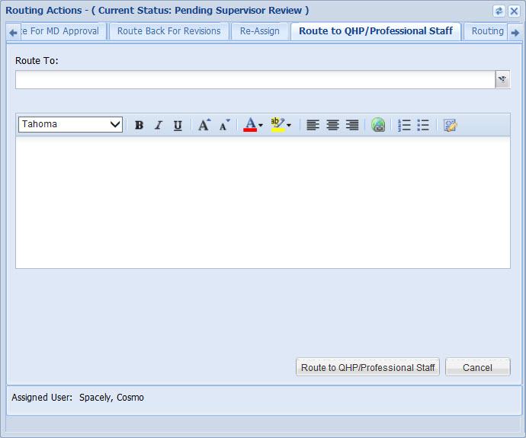
Supervisor Review Actions
The Supervisor has multiple actions.
- Route to QHP/Professional Staff
- Approve and Route for MD Approval
- Route Back for Revisions
Route to QHP/Professional Staff
Used to send the treatment plan to the Treatment Plan workgroup staff for review and approval prior to sending to the MD Workgroup.
- Click the Route to QHP/Professional Staff tab.
- Click the Route To drop-down and select the staff member in the Treatment Plan Workgroup you want to submit this to.
- Enter a note.
- Click the Route to QHP/Professional Staff button. This will add the Supervisor’s eSignature and send it to the Routing Pane of the selected QHP/Profession Staff for review.
Approve and Route For MD Approval
Used to send it to the MD Workgroup for review and approval.
- Click the Approve and Route for MD Approval tab.
- Click the Route To drop-down and select the staff member in the Treatment Plan Workgroup you want to submit this to.
- Enter a note.
- Click the Approve and Route For MD Approval button. This will add the Supervisor’s eSignature and send it to the Routing Pane of that member of the MD Workgroup for review.
Route Back For Revisions
Used to send it back to the clinician to make revisions.
- Click the Route Back For Revisions tab.
- Enter a note.
- Click the Route Back for Revisions button. This will add unlock the Treatment Plan and send it to the Routing Pane of the original clinician for revisions.

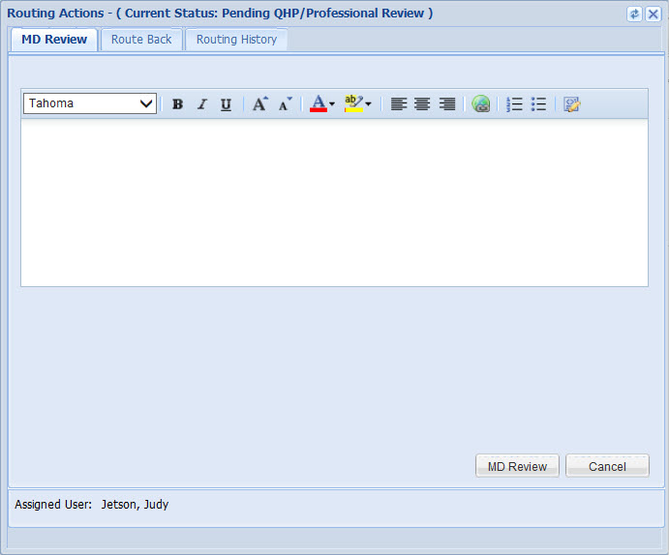
QHP/Professional Staff Review Actions
The QHP/Professional Staff has multiple actions.
- Approved by MD
- Route Back To Previous Reviewer (Supervisor)
MD Review
Used to send it to the MD Workgroup for review and approval.
- Click the MD Review tab.
- Click the Route To drop-down and select the staff member in the Treatment Plan Workgroup you want to submit this to.
- Enter a note.
- Click the MD Review button. This will send it to the Routing Pane of that member of the MD Workgroup for review.
Route Back To Previous Reviewer (Supervisor)
Used to send it back to the Supervisor.
- Click the Route Back tab.
- Enter a note.
- Click the Route Back button.

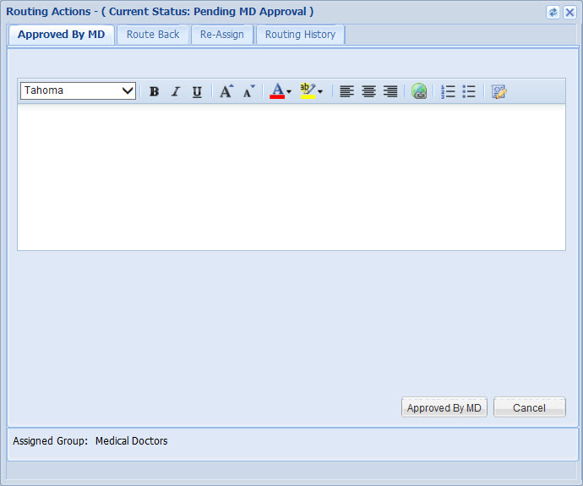
MD Workgroup Review Actions
The MD has multiple actions.
- Approved by MD
- Route Back To Previous Reviewer
Approved by MD
Used for final approval.
- Click the Approved by MD tab.
- Enter a note.
- Click the Approved by MD button. This will add the MD’s eSignature and close the Treatment Plan.
Route Back
Used to send the treatment plan back to the Previous Reviewer.
- Click the Route Back tab.
- Enter a note.
- Click the Route Back button. This will remove the previous eSignature and send it to the Routing Pane of the previous reviewer.

Routing History
Routing History provides an audit trail of the actions performed along with any notes that were added.
Access Routing History:
- Click the Routing History tab.
- Click on any row to expand and view any notes that were added during routing.

Treatment Plan Events by Service are located at Agency Setup > Services Setup > By Program > Plan Setup and can have a Routing Workflow Scheme assigned to the Initial Plan Event as well as to each Ongoing Treatment Plan Event.
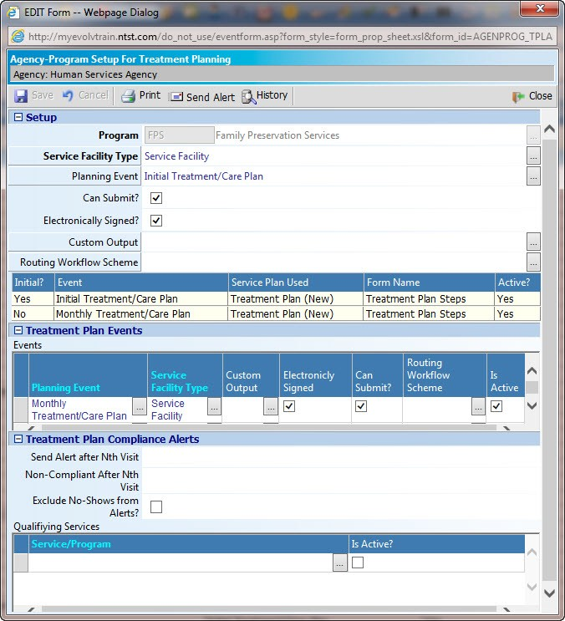

Treatment Plan Reports

Client Treatment Plan Reports
This report shows all Treatment Plan events that have been entered during the date range.
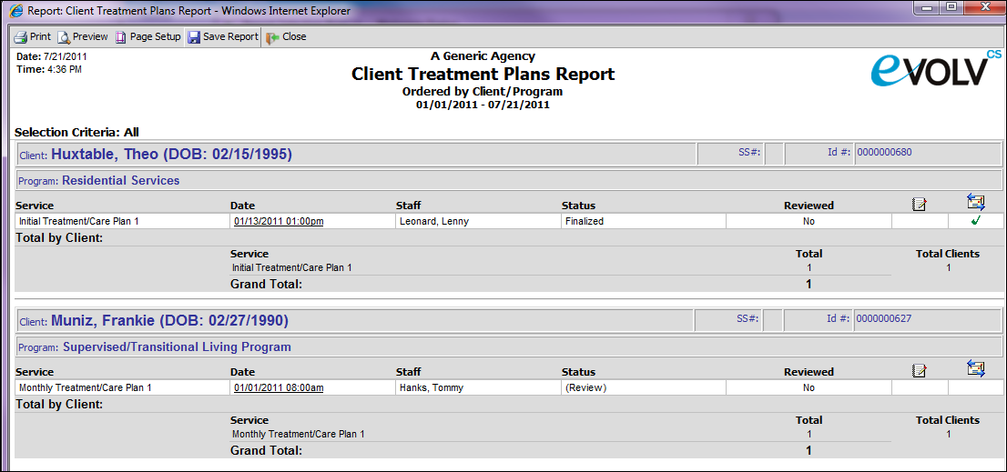

Plan Goals Report
This report shows aggregate totals of goal status for any plans that have been entered during the date range.
